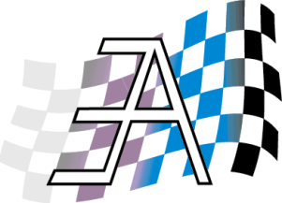**East Ayrshire Car Club**

**50th Anniversary Arran Weekend**

**20th to 23rd September 2013**

Plans are now well underway for the 50th Anniversary Weekend based at the Best Western Kinloch Hotel in Blackwaterfoot, on the Isle of Arran.

Activities will start when you land on the island on Friday 20th with a Treasure Hunt from the ferry terminal in Brodick to the finish at the Kinloch Hotel, so you will have to have your wits about you.

Local knowledge will not necessarily be a help since the last Treasure Hunt led to several of the club members resident on the island getting lost along the way!!!

There will be no motorsport activities on the Friday, giving everyone time to get acclimatised and to adapt to the speed (or otherwise) of life on the island.

On Saturday it is hoped that there will be Autotests and Grass Autotests, which will not be too complex, and will allow virtually all types of cars to take part.

A band has been booked for a Ceilidh Dance to be held at the Kinloch Hotel on the Saturday evening.

On Sunday there will be a Grass Test along the lines of the tests held at Pinwherry. There are some excellent fields at the south side of Arran which have been used in the past and we are trying to secure a venue for the event.

For non-competitors, there will be visits to Arran Aromatics, Lochranza Distillery and Arran Foods with, of course, the Ceilidh on Saturday night.

Arran is only 52 miles around the coast road, so it is easily possible to do a “Round the Island Tour” and being described as “Scotland in Miniature”, a tour around the island is not to be missed.

Please find attached, the booking forms for the Best Western Kinloch Hotel and for the ferry from Ardrossan to Brodick.

Since the number of rooms at the Kinloch Hotel is limited, an early return of the completed forms is advised to reserve your place.