**East Ayrshire Car Club**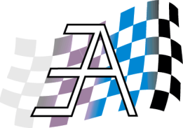

**50th Anniversary Arran Weekend**

**20th – 23rd September 2013**

**Ferry Booking Form**

**Name: ______________________________**

**Address: ______________________________**

**______________________________ Post Code: _____________**

**Tel No: ___________ Mobile: ___________ E-Mail: _____________**

**Fares:**

**Rate is £68.00 per car return. A trailer counts as a second car.**

**Adults £9.40 return; Children 5yrs to 16yrs £5.55 return; Children under 5yrs free.**

**NB: Car rate is for car only. Driver pays the adult rate in addition.**

**Ferry Times:**

**Ferry Required Ardrossan to Brodick: Day/Date______________________**

**Circle required time: 09.45; 11.05; 12.30; 13.50; 15.15; 18.00hrs.**

**Ferry Required Brodick to Ardrossan: Day/Date­­­­­­­­­­­­­­­­­­­­­_______________________**

**Circle required time: 11.05; 12.30; 13.50; 16.40; 19.20hrs.**

**Car Details:**

**Make/Model: ____________ Reg. No: ________________**

**No. of Cars @ £68.00 per car ____ £­­­­­­­­________**

**No. of Adults @ £9.40 ____ £________**

**No of Children 5-15yrs @£5.55 ____ £________**

**Total Due: £________**

**Cheque for total amount due payable to Caledonian Macbrayne**

**Return all details to: Bob Baillie, 21 Woodlands Grove, Kilmarnock, KA3 1TY**

**Tel: 01563 526181. Mobile: 07721 755917**